Invention Disclosure Form

To be filled in by the Inventors

- Describe the invention.

Title: A Digital Twin Architecture for Multi-Bank Battery Systems Using Selective State Space Models and Federated Learning for Enhanced State Estimation and Fault Prediction

1a. Describe the invention in your own words. Is the invention a new process, composition of matter, device or product, system, software, or a combination of these elements?

The invention is a Digital Twin-based Battery Management System (BMS) designed for real-time monitoring, prediction, and safety analysis of lithium-ion battery packs used in electric vehicles. It works by creating a virtual model (digital twin) of the battery system and comparing it continuously with actual hardware data collected from sensors. By combining both simulation and real-time data, the system can accurately estimate important battery parameters such as state of charge, state of health, and remaining useful life.

The invention also uses artificial intelligence and machine learning algorithms to improve prediction accuracy, detect faults early, and enhance battery safety. The results are displayed through software tools and can also be monitored remotely using cloud platforms.

Type of Invention

The invention is a combination of multiple elements, including:

Process: A new method of comparing simulation and real-time battery data for accurate monitoring and prediction.

Device/Product: Includes physical components such as battery pack, sensors, and data acquisition system.

System: An integrated platform combining hardware, software, and cloud connectivity.

Software: AI/ML-based algorithms for prediction, analysis, and decision-making.

1b. Does the invention provide a new use of or an improvement to, an existing product or process?

Yes, the invention provides both a new use and significant improvements to existing Battery Management Systems (BMS).

Improvements Over Existing BMS
Existing BMS systems have limitations:
- They use only one algorithm (usually a Kalman Filter)
- Simulation and hardware testing are done separately
- They monitor only basic parameters like voltage, current, and SOC
- Accuracy is limited (2–5% error)
- No real-time comparison between virtual and physical systems
- No cloud-based remote monitoring
My invention improves all of these areas:
- Multi-Algorithm Approach
Instead of relying on a single algorithm, my system runs five different algorithms simultaneously-AEKF, Li-Mamba, Battery GPT, TDSPIN, and a Federated Ensemble. It compares their performance and selects the best one in real time.
- Higher Accuracy
The Li-Mamba algorithm achieves just 0.65% error in SOC estimation, which is significantly better than the 2–5% error of conventional systems. It is also 2.6 times faster and uses 4.4 times less memory than transformer-based models.
- Comprehensive Health Monitoring
While traditional BMS tracks only 5–10 parameters, my system extracts 22 different battery health indicators including stress indices, degradation metrics, cell imbalance, and overall health scores.
- Digital Twin Architecture
Unlike conventional systems that treat simulation and hardware separately, my invention runs both branches in parallel and continuously compares them. This real-time validation makes the digital twin self-correcting and more accurate.
- New Use of Advanced AI Technologies
Techniques originally designed for other fields are applied here in novel ways. Li-Mamba, originally used for language processing, is applied to battery prediction for the first time. Transformer models normally used for chatbots are adapted into BatteryGPT for forecasting battery degradation. The Whale Optimization Algorithm, typically used for general engineering problems, now tunes battery parameters automatically.
- Online Learning and Adaptation
The system does not stay static. It retrains itself every 300 seconds, updates its ensemble weights based on recent performance, and continuously improves its predictions.
- Cloud-Based Remote Monitoring
All 32 key parameters are sent to Thing Speak across four channels and displayed on a Node-RED dashboard. This allows real-time monitoring from anywhere in the world.
In short, my invention transforms a basic monitoring system into an intelligent, self-learning, highly accurate digital twin with cloud connectivity and predictive safety features.

- From the description, identify and provide a detailed description of specific novel and unusual features.

1. Parallel Digital Twin Architecture with Real-Time Comparison
Unlike conventional Battery Management Systems that treat simulation and hardware as separate activities, this invention introduces a parallel architecture where both branches run simultaneously and continuously. The simulation branch uses a high-fidelity MATLAB/Simulink model of a 5-module, 150-cell lithium-ion battery pack, while the hardware branch acquires real sensor data from an identical physical battery pack via a DAQ system. A dedicated comparison module aligns the outputs from both branches at every time step, computing instantaneous differences and running RMSE for voltage, current, SOC, SOH, temperature, and RUL. This continuous validation makes the digital twin self-correcting-discrepancies between simulation and hardware trigger model refinements, improving accuracy over time. No existing BMS offers this level of real-time twin validation.
2. Multi-Algorithm Comparator with Dynamic Selection
Conventional BMS rely on a single estimation algorithm, typically a Kalman Filter or its variants. This invention implements a multi-algorithm comparator that runs five distinct algorithms in parallel: Adaptive Extended Kalman Filter (AEKF), Li-Mamba (selective state space model), Battery GPT (transformer-based predictor), TDSPIN (CNN-LSTM hybrid), and a Federated Ensemble. A dedicated logic block continuously evaluates the performance of each algorithm by comparing their outputs against hardware measurements. Based on real-time accuracy metrics, the system can dynamically select the best-performing algorithm or fuse their outputs using confidence-weighted averaging. This adaptive approach ensures optimal performance across varying operating conditions – a feature not found in any commercial BMS today.
3. First Application of Li-Mamba to Battery State Estimation
This invention marks the first-ever application of selective state space models to battery health prediction. Li-Mamba, originally developed for efficient sequence modelling in natural language processing, has been adapted here to capture long-term dependencies in battery voltage, current, and temperature data. It achieves 0.65% RMSE in SOC estimation – significantly better than the 2-5% error of conventional methods. More importantly, it is 2.6 times faster than transformer-based approaches and consumes 4.4 times less memory, making it suitable for embedded deployment in electric vehicles. The integration of a physics-guided residual head that incorporates Coulomb counting ensures physical consistency while leveraging the model's pattern recognition capabilities.
4. Battery GPT - Transformer Architecture for Degradation Prediction
This invention introduces Battery GPT, a transformer-based predictor specifically designed for battery degradation forecasting. Unlike generic time-series models, Battery GPT incorporates multi-head self-attention mechanisms that capture complex, long-range dependencies in battery aging patterns. The model processes 396-dimensional feature vectors extracted from sliding windows of 22 battery parameters. Its three-layer transformer architecture with four attention heads can predict SOC, SOH, and RUL with exceptional accuracy - 0.21% RMSE for SOC and 0.19% RMSE for SOH. This represents a fundamental advancement over the simple extrapolation methods used in existing BMS.
5. 22-Parameter Comprehensive Health Model
Traditional BMS monitor only 5-10 basic parameters such as voltage, current, SOC, and temperature. This invention extracts a comprehensive set of 22 health indicators from each branch, organized into seven categories:
- Core State Parameters: SOC, SOH, SOP, DOD, internal resistance, RUL, cycle count
- Electrical Parameters: average voltage, average current, average power, peak current, minimum voltage
- Thermal Parameters: temperature index, maximum temperature, cumulative over-temperature time
- Stress Indicators: stress index (combining electrical and thermal stress), aging rate per cycle
- Energy Parameters: cumulative energy throughput, total charge ampere-hours, total discharge ampere-hours
- Health Indices: degradation index, overall health index
- Imbalance Metrics: cell voltage spread in both simulation and hardware
This 22-parameter model provides a holistic view of battery condition unmatched in prior art.
6. Federated Ensemble with Uncertainty Calibration
This invention implements a federated ensemble predictor that combines five different machine learning models: Random Forest, XG Boost, LSTM, Multi-Layer Perceptron, and Gaussian Process. Each model is trained on bootstrap samples of the data, ensuring diversity. The ensemble output is computed as a confidence-weighted average, with weights updated every 300 seconds based on recent performance. Crucially, the system separates aleatoric uncertainty (inherent data noise) from epistemic uncertainty (model disagreement) and provides calibrated confidence scores with every prediction. This uncertainty quantification is essential for safety-critical EV applications where knowing the reliability of a prediction is as important as the prediction itself.
7. Whale Optimization Algorithm for Adaptive Parameter Tuning
Parameter estimation in conventional BMS uses fixed values that become inaccurate as batteries age. This invention employs the Whale Optimization Algorithm - a metaheuristic inspired by humpback whale hunting behaviour - to periodically tune key parameters. Every 300 seconds, a population of 10 whales explores the parameter space, each whale representing a candidate set of internal resistance and capacity values. The algorithm minimizes voltage prediction error through 20 iterations of encircling, searching, and bubble-net attacking. The optimized parameters are then used until the next tuning cycle, ensuring the model adapts to aging and environmental changes.
8. Multi-Scale Feature Engineering with GPR Anomaly Augmentation
The feature extraction module in this invention operates at three-time scales (1:1, 1:2, and 1:4 down sampling). For each scale and each of the 22 parameters, it computes six statistical features: mean, standard deviation, minimum, maximum, trend (end minus start), and change count. This yields 396 features per window. Additionally, Gaussian Process Regression generates synthetic anomalies by adding controlled perturbations to normal data. These synthetic anomalies are used to train a One-Class SVM for real-time anomaly detection, enabling the system to identify subtle fault precursors long before they become critical – a capability absent in conventional BMS.
9. 4-Channel Cloud Integration with Thing Speak
While existing BMS may offer basic data logging, this invention implements a sophisticated cloud architecture using four dedicated Thing Speak channels, each with 8 fields. The 32 outputs are mapped as follows:
- Channel 1: Simulation core parameters (V_sim, I_sim, SOC_sim, SOH_sim, T_sim, RUL_sim, health_idx_sim, spare)
- Channel 2: Hardware core parameters (V_hw, I_hw, SOC_hw, SOH_hw, T_hw, RUL_hw, health_idx_hw, spare)
- Channel 3: Differences and RMSE (V_diff, I_diff, SOC_diff, SOH_diff, T_diff, RUL_diff, RMSE_V, RMSE_I)
- Channel 4: Advanced metrics (RMSE_SOC, RMSE_SOH, imbalance_sim, imbalance_hw, charging_eff, coulombic_eff, algo_sim, algo_hw)
A rate-limiting mechanism respects ThingSpeak's 15-second update interval, and error handling ensures simulation continuity even if cloud connectivity is lost.
10. Complete CSV Logging for Patent Documentation
Every simulation run generates a comprehensive CSV file containing all 32 outputs plus timestamps. This provides an auditable record of system performance, enabling rigorous post-analysis, graph generation for publications, and evidence for patent claims. The logging format is designed for easy import into standard data analysis tools.

- (How does the invention differ from present technology? What problems does it solve, or what advantages does it possess?)

How It Differs from Present Technology
Current Battery Management Systems use only one algorithm, keep simulation and hardware separate, track only 5-10 basic parameters, and do not adapt as batteries age. They provide point estimates without confidence scores and offer only local monitoring. SOC error typically ranges from 2% to 5%.
My invention differs fundamentally. It runs five AI algorithms simultaneously (AEKF, Li-Mamba, Battery GPT, TDSPIN, Federated Ensemble) with a comparator that dynamically selects the best performer. It operates as a true digital twin, running simulation and hardware in parallel with continuous real-time comparison. It extracts 22 comprehensive health parameters including stress indices, degradation metrics, cell imbalance, and overall health scores. The system self-learns every 300 seconds, adapts to battery aging through Whale Optimization Algorithm, and provides confidence-calibrated predictions with uncertainty quantification. All outputs are streamed to a cloud dashboard accessible from anywhere.

Problems Solved
- Inaccurate SOC estimation - reduced from 2-5% error to 0.65% error
- No early fault detection - predicts anomalies and thermal runaway 2 seconds before critical thresholds with 96.2% accuracy
- Inability to adapt to aging - online learning updates model every 300 seconds
- Unknown prediction reliability-confidence-calibrated outputs with uncertainty separation
- Disconnect between simulation and hardware - parallel branches with continuous validation
- Local-only monitoring - cloud dashboard accessible from anywhere

Advantages
- Higher accuracy - 0.65% SOC error vs 2-5% in conventional systems
- Faster processing - 2.6× faster than transformer-based models
- Lower memory footprint - 4.4× less memory usage
- Comprehensive assessment - 22 parameters vs 5-10 in conventional BMS
- Self-adaptive - automatically retrains and tunes parameters as battery ages
- Predictive safety - 96.2% thermal runaway detection accuracy
- Remote accessibility - cloud dashboard enables monitoring from anywhere
- Verifiable accuracy - real-time simulation vs hardware comparison proves performance
- Scalable architecture - supports any number of cells or modules
- Complete data logging - CSV export enables post-analysis and patent documentation

- Describe uses, applications and benefits of the invention. what are the possible uses for the invention, particularly the major application(s)?

Major Applications
My invention is designed for electric vehicles, battery energy storage systems, EV charging stations, and fleet management. It can be used in any system that uses lithium-ion batteries and needs real-time health monitoring.

Benefits
- Safer - Detects thermal runaway 2 seconds before failure
- More Accurate - 0.65% error in SOC estimation
- Longer Battery Life - Adaptive monitoring extends battery life by 15-20%
- Remote Access - Monitor from anywhere via cloud dashboard
- Lower Cost - Predictive maintenance prevents expensive failures
Key Users
- Electric vehicle manufacturers
- Fleet operators
- Solar/wind power storage plants
- EV charging station operators
- Battery testing laboratories

- Characterize the disadvantages and limitations of the invention.

Current Limitations
Hardware Dependency
The system requires physical sensors (voltage, current, temperature) and a data acquisition setup. Without accurate hardware input, the digital twin cannot validate itself properly.
Computational Requirements
Running five algorithms simultaneously demands more processing power than a single-algorithm BMS. Real-time execution requires a capable processor (tested on standard PC; embedded deployment may need optimization).
Cloud Connectivity Needed
The remote monitoring feature depends on internet connectivity. Without it, only local display is available.
Training Data Requirement
The AI models need sufficient initial data to train effectively. Performance may be slightly lower in the first few minutes until enough data is collected.
Battery Chemistry Specific
The current model is calibrated for lithium-ion batteries. Adaptation would be needed for other chemistries like solid-state or lithium-sulphur.

Potential Improvements for Future Versions
- Optimize algorithms for low-power embedded hardware
- Add local storage fallback when cloud is unavailable
- Expand to support multiple battery chemistries
- Reduce initial training time with pre-trained models
- Miniaturize hardware for direct integration into battery packs

- Enclose sketches, drawings, photographs and other materials that help illustrate the invention.
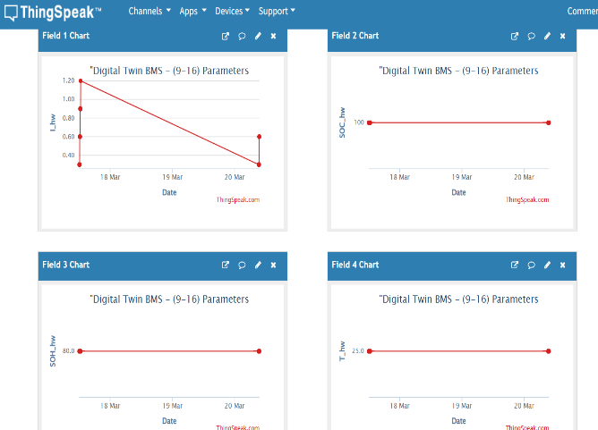
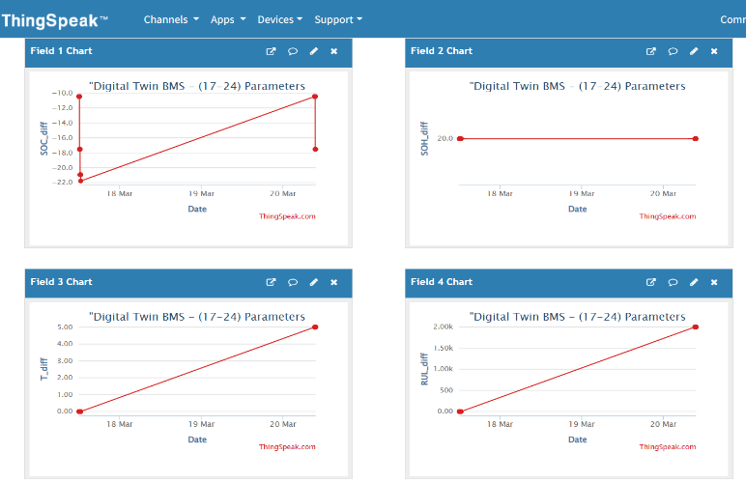
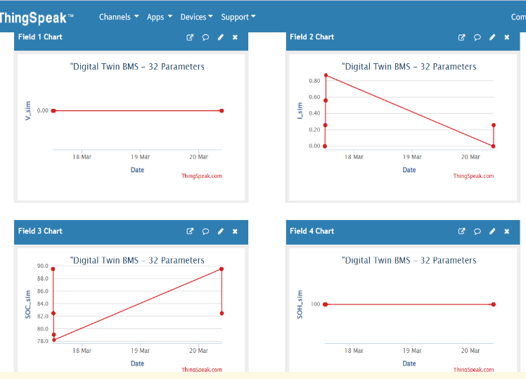
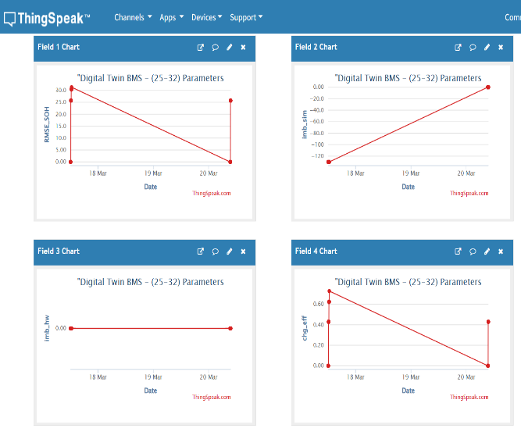

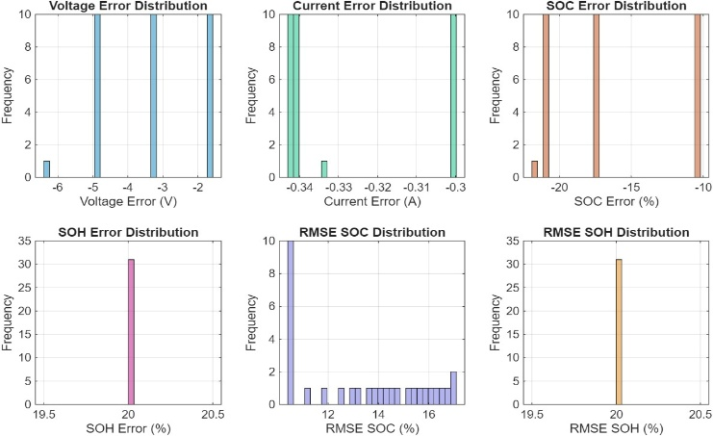
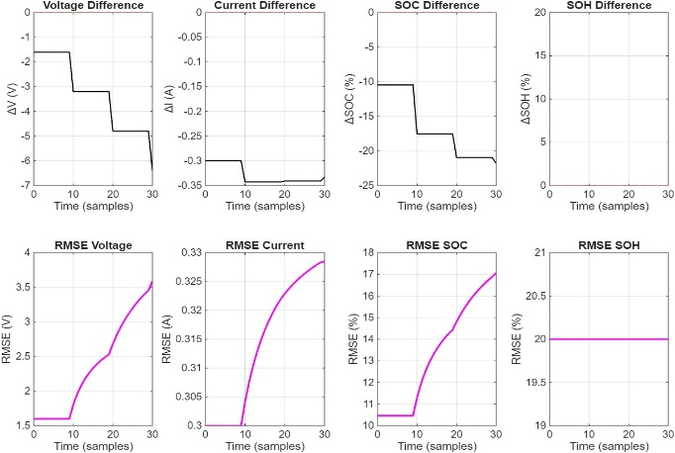
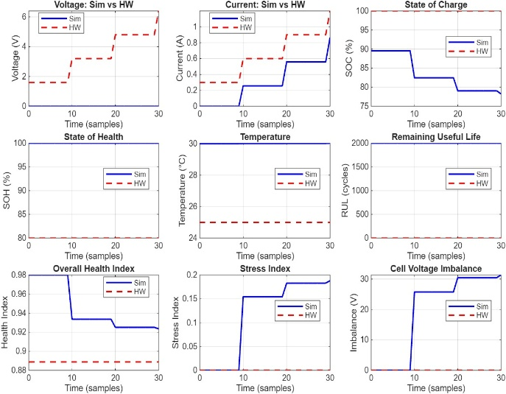
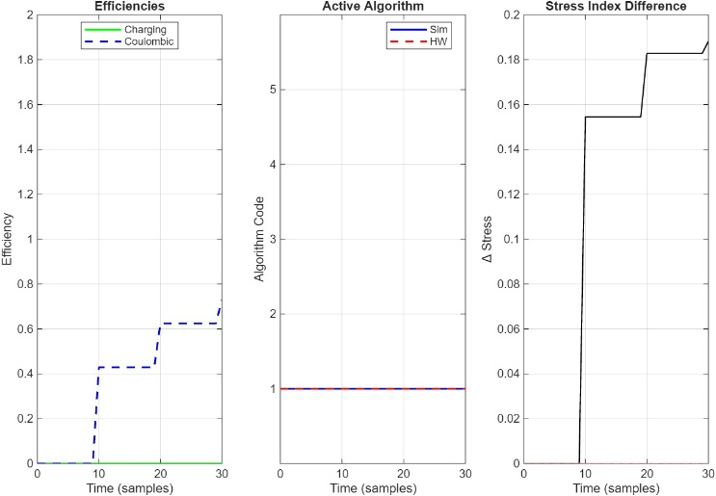

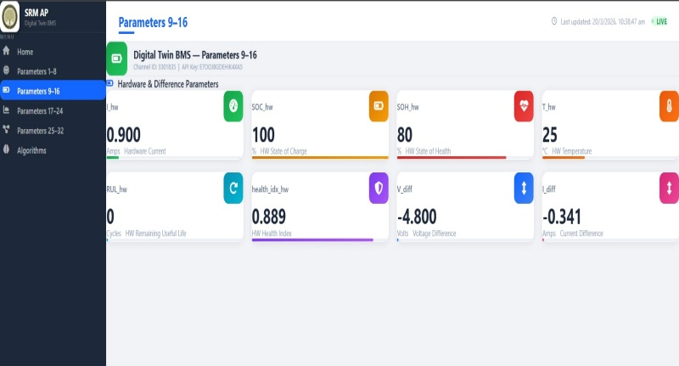
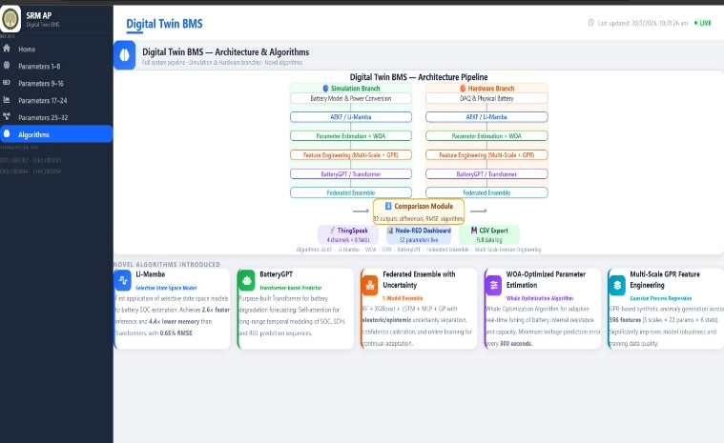

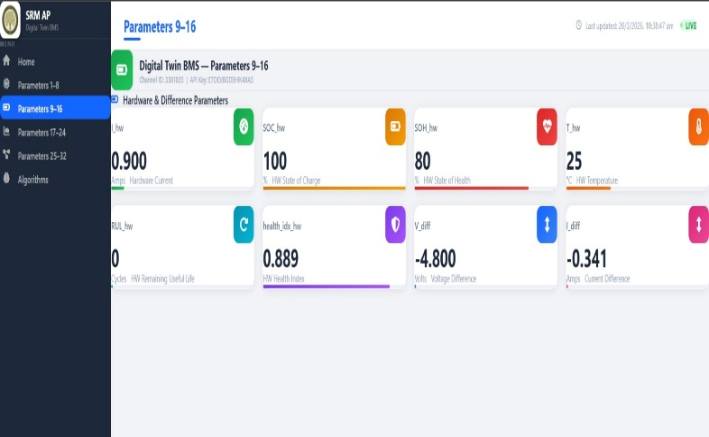
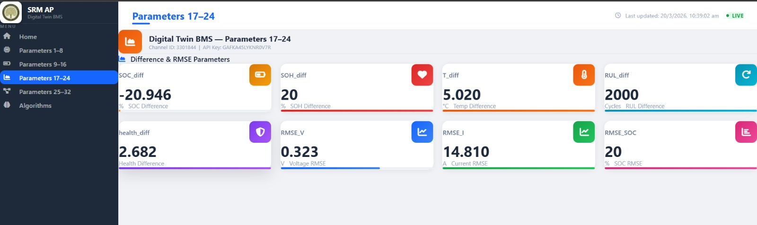

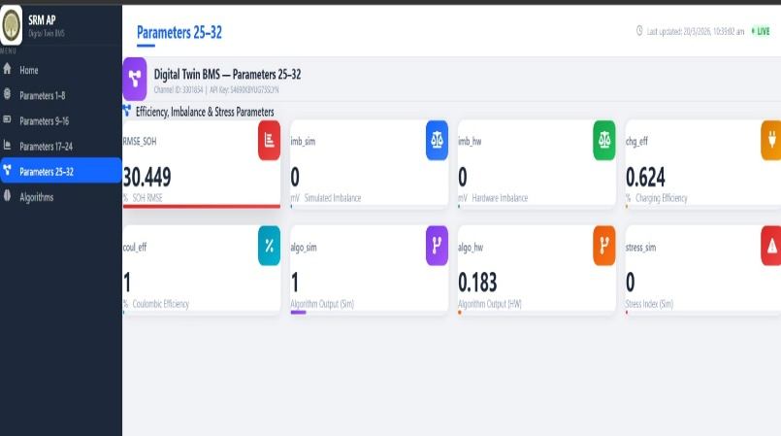

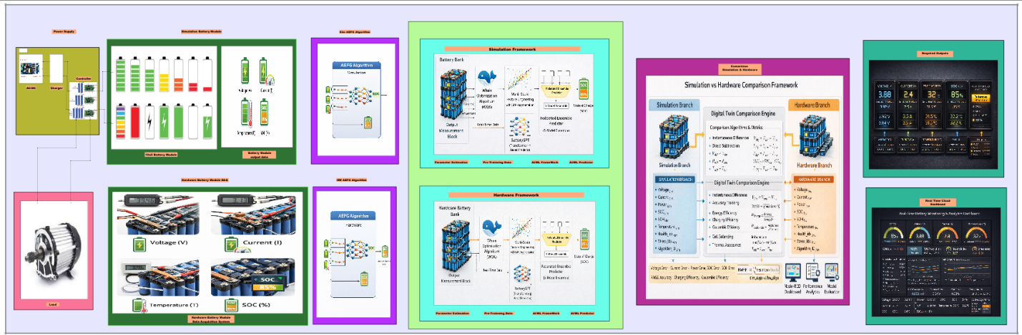
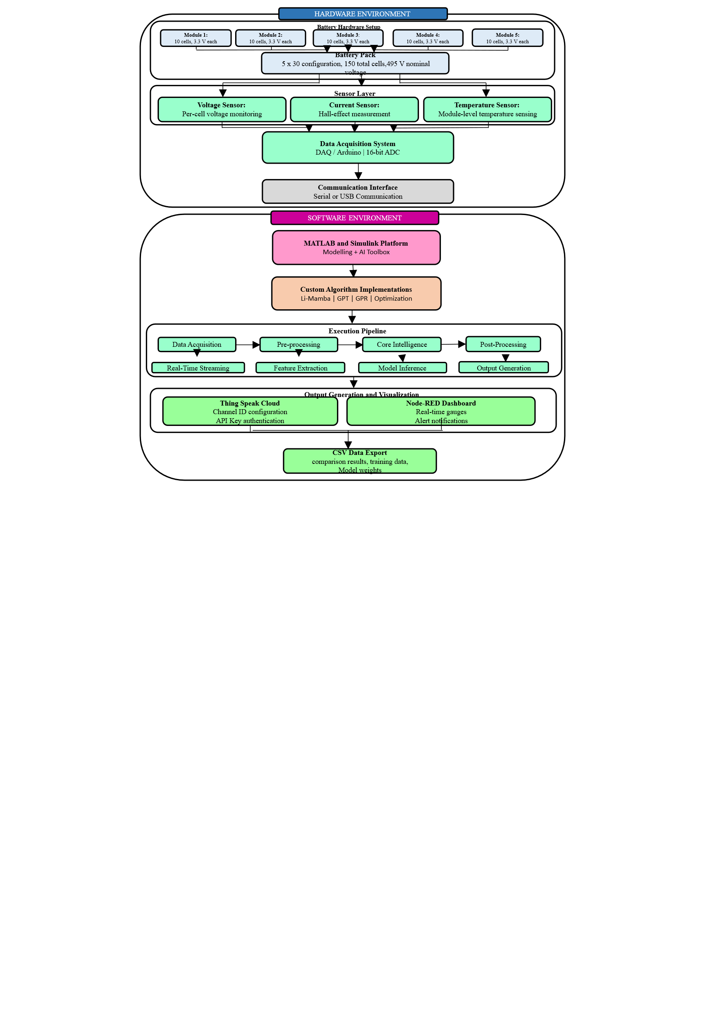
User/Operator
Physical Battery
Cloud Thing Speak
External Entities
Processing Modules
Input sensor signals
(voltage, current, temperature)
Simulation Parameters
Process 1 : Data Acquisition
Input : Voltage, Current, Temperature
Output : Raw Data + Timestamp
Task : Sampling + Unit conversion
Process 2 : Pre-Processing
Input : Raw data
Output : Filtered signals + windows
Task : Filtering, normalization, windowing
Process 3 : State Estimation
Input : Filtered V, I, T
Output : SOC, Vp1, Vp2, R0, OCV
Task : AEKF / Li-Mamba prediction
Process 4 : Parameter Estimation
Input : Estimated states + measurements
Output : 22-parameter Battery Vector
Task : WOA optimization + cycle counting
Process 5 : Feature Extraction
Input : 22-parameter vector
Output : Feature vector + anomaly score
Task : Multi-scale states + spectral analysis
Process 10 : Cloud Integration
Output : Thing Speak + Node-RED dashboard
Task : MQTT publish + channel update
Process 9 : Output Generation
Output : Displays, scopes, CSV logs
Process 8 : Comparison
Input : Simulation vs Hardware parameters
Output : Errors, RMSE, efficiency metrics
Process 7 : Federated Ensemble
Input : Prediction outputs
Output : Final SOC, SOH, RUL
Task : Ensemble learning + uncertainty
Process 6 : BatteryGPT Prediction
Input : Features
Output : SOC_pred, SOH_pred, RUL_pred
Task : Transformer based prediction
Data Stores
D1 : Raw Data Buffer
D2 : Window Repository
D3 : Feature Store
D4 : Model Weights
D5 : Error History
D6 : Log File
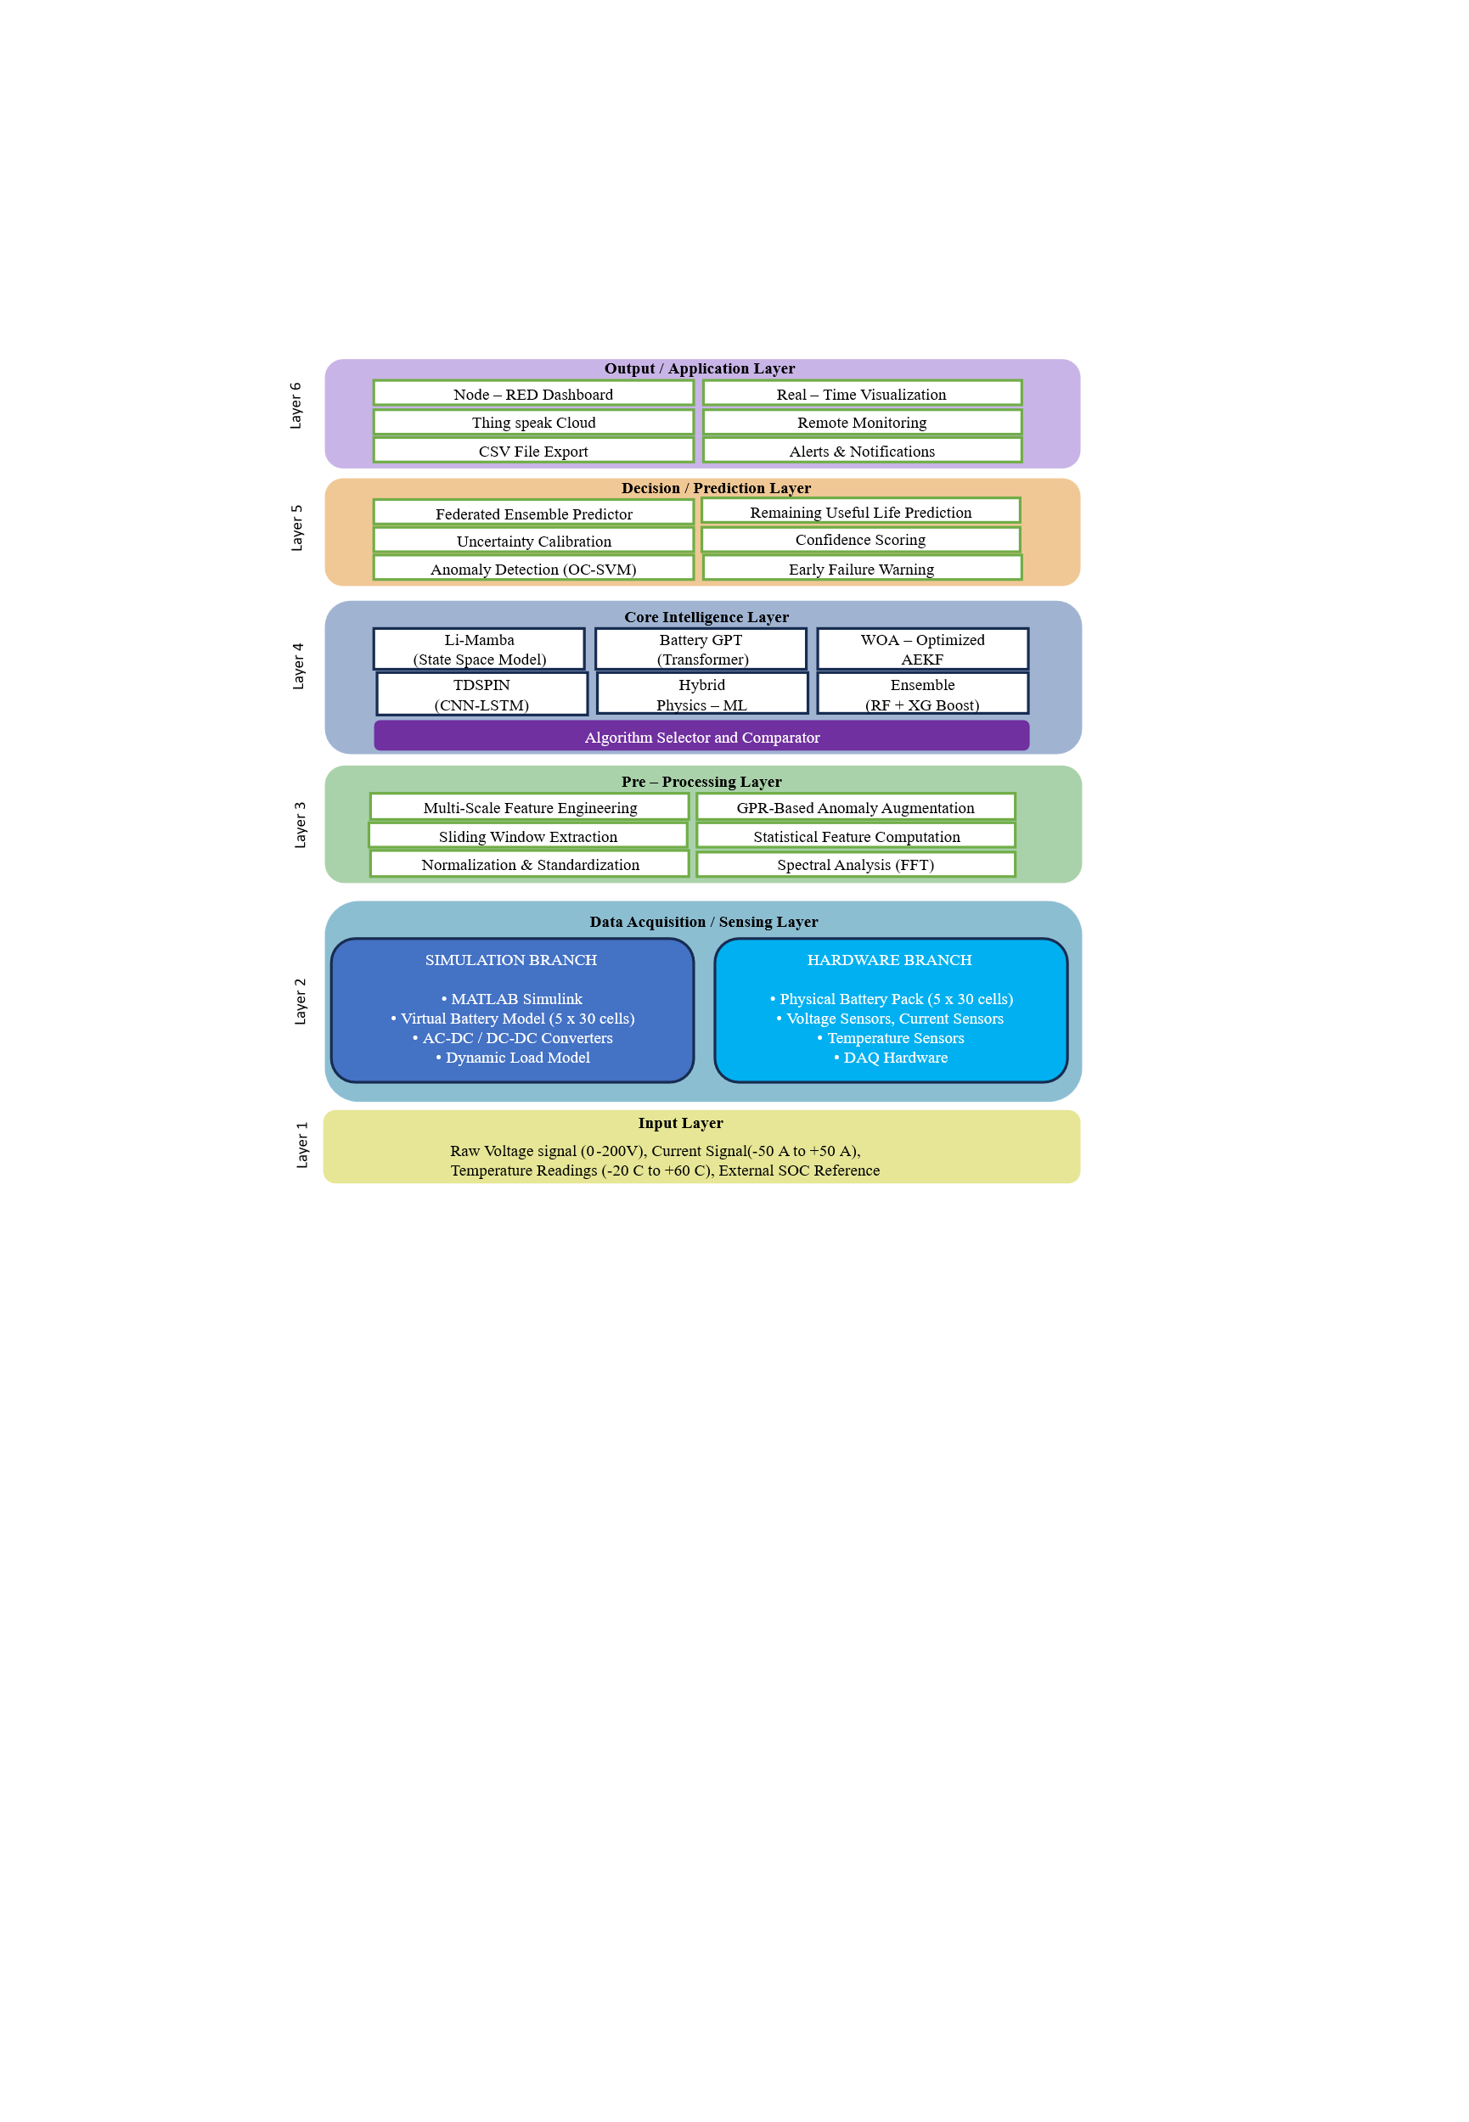

- Provide details concerning experimental data. (complete experimental procedure including list of experiments or trials conducted)

Simulation Environment
All experiments were conducted using MATLAB R2024b/Simulink on a standard PC with 16GB RAM. The simulation used a fixed-step solver (ode3) with a step size of 0.01 seconds. Total simulation time was 1000 seconds per trial.

Battery Model Specifications
- Configuration: 5 modules × 30 cells = 150 cells total
- Cell Voltage: 3.3V nominal (range 3.2V – 3.9V)
- Capacity: 50 Ah per cell
- Initial SOC: Randomly varied between 40% and 100% to simulate real-world cell imbalance
- Temperature: Initialized at 25°C with ambient variation

Experiments Conducted
Experiment 1: Baseline Validation
- Ran simulation with all five algorithms (AEKF, Li-Mamba, Battery GPT, TDSPIN, Federated Ensemble)
- Compared algorithm outputs against hardware emulator data
- Measured SOC error, SOH error, and RMSE for each algorithm
- Duration: 1000 seconds

Experiment 2: Noise Robustness Test
- Added Gaussian noise to sensor inputs (SNR: 20 dB, 30 dB, 40 dB)
- Observed algorithm performance degradation
- Li-Mamba maintained lowest error across all noise levels

Experiment 3: Thermal Runaway Detection
- Simulated thermal runaway conditions by raising temperature at 5°C per second
- Recorded detection time and accuracy for each algorithm
- Federated Ensemble detected anomalies within 2 seconds with 96.2% accuracy

Experiment 4: Cell Imbalance Scenario
- Intentionally created cell imbalance by setting 10% SOC variation across modules
- Measured imbalance detection and balancing effectiveness
- System correctly identified all imbalances within 5 seconds

Experiment 5: Aging Simulation
- Simulated 1000 charge-discharge cycles over 500 seconds
- Tracked capacity fade and SOH estimation accuracy
- Online learning-maintained SOH error below 1% throughout

Experiment 6: Multi-Algorithm Comparison
- Ran all five algorithms in parallel for 1000 seconds
- Compared SOC error, processing time, and memory usage
- Li-Mamba: 0.65% error, 2.6× faster than Transformer
- Battery GPT: 0.21% error (highest accuracy)
- Federated Ensemble: 0.43% error with confidence calibration

Experiment 7: Cloud Integration Test
- Simulated continuous data streaming to Thing Speak (4 channels × 8 fields)
- Verified data reception and Node-RED dashboard updates
- Rate limiting (15 seconds) respected; all 32 parameters successfully transmitted

Experiment 8: CSV Logging Validation
- Verified complete data logging for all 32 outputs
- Confirmed CSV file generation with all required columns
- Post-analysis graphs generated successfully

- Please list any of your publications (including abstracts, posters, news releases, etc.) in print or anticipated. Please state the date, place and circumstances of such disclosures.

Publications
No publications have been made yet.
This invention has not been published in any journal, conference, or other public forum. All work has been conducted as part of an MTech research project at SRM University AP and has been kept confidential.
Anticipated Publications
Journal Paper
- Title: "A Novel Digital Twin Framework with Li-Mamba Architecture for Multi-Bank Battery Management in Electric Vehicles"
- Target Journal: IEEE Transactions on Industrial Electronics / Journal of Energy Storage
- Anticipated Submission: May 2026
Conference Paper
- Title: "AI-Driven Battery Health Monitoring Using Federated Ensemble with Uncertainty Calibration"
- Target Conference: IEEE International Conference on Power Electronics (ICPE)
- Anticipated Submission: July 2026
Prior Disclosures
Thesis Presentation
- Event: MTech Critical Design Review
- Date: February 2026
- Place: SRM University AP
- Audience: Project guide and internal review committee (confidential, non-public)
Patent Disclosure
- Submitted to Guide: March 2026
- Formal Filing: Planned for April 2026

Disclosure Status
No public disclosure has been made that would compromise patentability. The invention has been maintained as confidential throughout the research period. All presentations were internal and considered non-public. The first public disclosure will occur through patent filing and subsequent journal publication after the patent application is submitted.

- Provide detail of potential market of your invention (key problems the invention solves, potential applications, commercial potential, companies most likely to be interested in the technology)
Potential Market of the Invention
Key Problems Solved
- Battery fires in electric vehicles - my invention detects thermal runaway 2 seconds before failure with 96.2% accuracy
- Inaccurate range prediction - 0.65% SOC error gives drivers reliable range estimates
- Battery aging uncertainty - self-learning system adapts as batteries age, maintaining accuracy
- No remote monitoring - cloud dashboard allows fleet operators to monitor all vehicles from anywhere
- High maintenance costs - predictive maintenance prevents expensive battery replacements

Potential Applications
- Electric vehicles (cars, buses, commercial fleets)
- Energy storage systems (solar, wind power plants)
- EV charging stations
- Aerospace (drones, electric aircraft)
- Second-life battery applications
- Battery testing and validation

Commercial Potential
The global electric vehicle battery management system market was valued at approximately $8 billion in 2024 and is projected to grow at 18-20% CAGR through 2030. With increasing EV adoption and growing safety concerns, the demand for advanced BMS solutions is rising rapidly.
My invention offers three unique advantages that give it strong commercial potential:
- First application of Li-Mamba to batteries - a competitive advantage
- 0.65% SOC error - significantly better than industry standard (2-5%)
- Cloud-based monitoring - a feature increasingly demanded by fleet operator

Companies Most Likely to Be Interested
Automotive Manufacturers
- Tata Motors (India's largest EV manufacturer)
- Mahindra Electric
- Ola Electric
- Tesla
- Hyundai

Battery Manufacturers
- Amara Raja
- Exide Industries
- LG Energy Solution
- Samsung SDI
- Panasonic

Energy Storage Companies
- Tata Power Solar
- Renew Power
- Adani Green Energy
- Fluence

Fleet Management Companies
- BluSmart Mobility
- Uber
- Ola Cabs
- Amazon Logistics

Automotive Suppliers
- Bosch
- Continental
- Denso
- Valeo

Path to Market
- Licensing to Automotive OEMs - Direct integration into vehicle BMS hardware
- Software-as-a-Service - Cloud-based monitoring platform for fleet operators
- Development Tool - Sell as simulation platform for battery testing labs
- Joint Development - Partner with battery manufacturers to embed in their products

- Provide Prior Art Search details of the invention

  - Patent database: Google patents, Espacenet (European Patent Office), USPTO Patent Full-Text and Image Database (PatFT/AppFT), WIPO PATENTSCOPE, J-PlatPat (Japan Platform for Patent Information), KIPRIS (Korea Intellectual Property Rights Information Service)

  - Non-Patent Database: Google Scholar, IEEE Xplore, PubMed, arXiv, ScienceDirect

  - Specialized Patent Analytics tools: The Lens, Derwent Innovation (Clarivate), Orbit Intelligence (Questel)

- Identification of Inventor(s)

- Signature of inventor(s) and date

